**PIZZA SALES SQL QUERIES**

**A. KPI’s**

**1. Total Revenue:**

**SELECT SUM(total_price) AS Total_Revenue FROM pizza_sales;**

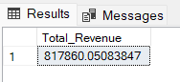

**2. Average Order Value**

**SELECT (SUM(total_price) / COUNT(DISTINCT order_id)) AS Avg_order_Value FROM pizza_sales**

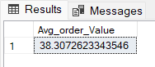

**3. Total Pizzas Sold**

**SELECT SUM(quantity) AS Total_pizza_sold FROM pizza_sales**

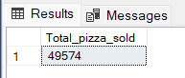

**4. Total Orders**

**SELECT COUNT(DISTINCT order_id) AS Total_Orders FROM pizza_sales**

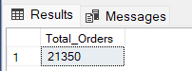

**5. Average Pizzas Per Order**

**SELECT CAST(CAST(SUM(quantity) AS DECIMAL(10,2)) /**

**CAST(COUNT(DISTINCT order_id) AS DECIMAL(10,2)) AS DECIMAL(10,2))**

**AS Avg_Pizzas_per_order**

**FROM pizza_sales**

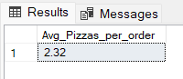

**B. Daily Trend for Total Orders  
SELECT DATENAME(DW, order_date) AS order_day, COUNT(DISTINCT order_id) AS total_orders**

**FROM pizza_sales**

**GROUP BY DATENAME(DW, order_date)**

***Output:***

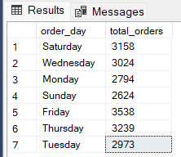

**C. Hourly Trend for Orders**

**SELECT DATEPART(HOUR, order_time) as order_hours, COUNT(DISTINCT order_id) as total_orders**

**from pizza_sales**

**group by DATEPART(HOUR, order_time)**

**order by DATEPART(HOUR, order_time)**

***Output***

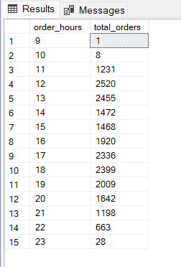

**D. % of Sales by Pizza Category**

**SELECT pizza_category, CAST(SUM(total_price) AS DECIMAL(10,2)) as total_revenue,**

**CAST(SUM(total_price) * 100 / (SELECT SUM(total_price) from pizza_sales) AS DECIMAL(10,2)) AS PCT**

**FROM pizza_sales**

**GROUP BY pizza_category**

***Output***

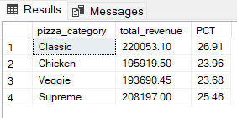

**E. % of Sales by Pizza Size**

**SELECT pizza_size, CAST(SUM(total_price) AS DECIMAL(10,2)) as total_revenue,**

**CAST(SUM(total_price) * 100 / (SELECT SUM(total_price) from pizza_sales) AS DECIMAL(10,2)) AS PCT**

**FROM pizza_sales**

**GROUP BY pizza_size**

**ORDER BY pizza_size**

***Output***

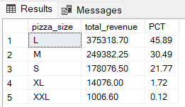

**F. Total Pizzas Sold by Pizza Category**

**SELECT pizza_category, SUM(quantity) as Total_Quantity_Sold**

**FROM pizza_sales**

**WHERE MONTH(order_date) = 2**

**GROUP BY pizza_category**

**ORDER BY Total_Quantity_Sold DESC**

***Output***

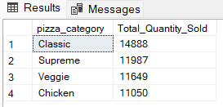

**G. Top 5 Best Sellers by Total Pizzas Sold**

**SELECT Top 5 pizza_name, SUM(quantity) AS Total_Pizza_Sold**

**FROM pizza_sales**

**GROUP BY pizza_name**

**ORDER BY Total_Pizza_Sold DESC**

***Output***

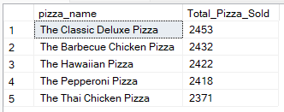

**H. Bottom 5 Best Sellers by Total Pizzas Sold**

**SELECT TOP 5 pizza_name, SUM(quantity) AS Total_Pizza_Sold**

**FROM pizza_sales**

**GROUP BY pizza_name**

**ORDER BY Total_Pizza_Sold ASC**

***Output***

